BLUEPRINTS & WIDGETS

Create a UI

Create the UI Widget.

- Go to the Level folder in the Content Browser (or create one).

- Right click and select Level. Name this new level StartMenuLevel, and double click on it to open it. The level should be pitch-black.

- Go to the Blueprints folder, and create a new folder called WBP. WBP means widget Blueprint. A widget is a UI or a UI element we can put on the screen.

- Right click in the WBP folder, and select User Interface - Widget Blueprint. Name the new Widget Blueprint to WBP_StartMenu.

Add a button

- Double click the WBP_StartMenu to open it with the Widget Editor.

- Go to the Palette panel at the upper left corner, and you can see some prebuilt UI elements we can use.

- If your Palette panel doesn’t have a Canvas, drag one from the components panel into the Palette panel.

- Drag a button to the canvas at the center of the window

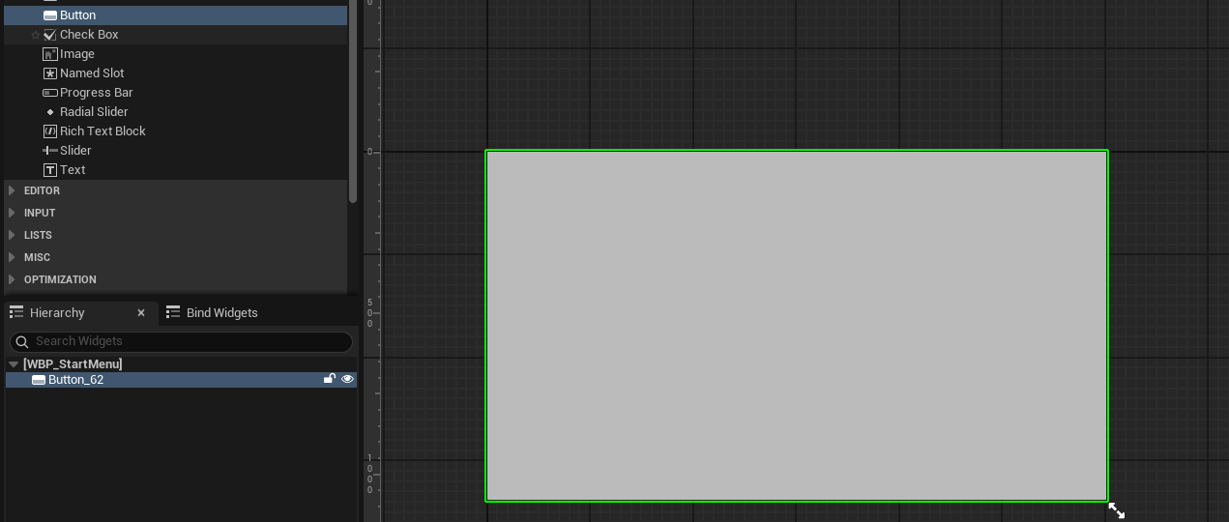

Drag a text to the button.

- In the Palette panel, find and drag Text to the button we created to add a text to the button. You should see the text snaps to the button, and under the Hierarchy panel, you can also see that the text is inside the button.

- This Hierarchy is the same as the Maya Outliner you might be familiar with. Currently, the text is parented under our button.

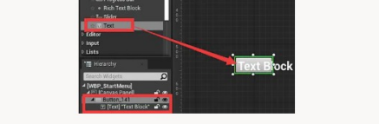

Name the button and the text.

- Right click on the Button_141 (yours could be a different number) in the Hierarchy and select rename; rename this button to StartButton.

- Click and drag the edge or corner of the button on the canvas to make it bigger. Make sure that the text is not clipping out of the edge of the button.

- Click on the [Text] "Text Block" in the Hierarchy to select it. Go to the Details panel, and under the Content section, set the Text to Start Game.

- Press the Save button to save the changes.

Bind the button click.
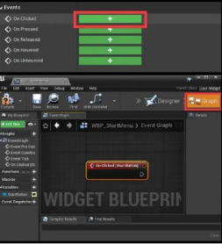
- Select our StartButton in the Hierarchy. Go to the Details panel, scroll down to the bottom, and find the Events section.

- Click on the plus button on the right side of the On Clicked text. The UI changes to the Event Graph, with a node named On Clicked (StartButton) highlighted in the middle.

Event Graph

The Event Graph is where we create our Blueprint code. Many assets have an Event Graph that allows us to write code to that asset, and the navigation of the Event Graph is the same as the Material Editor.

Our first code.

- Right click anywhere in the Event Graph, search for Print String, and hit Enter to create a Print String node.

- Click and drag the triangle pin of the On Clicked (StartButton) node to the triangle pin on the left of the Print String node (as shown).

- Press the Compile (we will explain what compile means soon) and Save button on the upper left corner to save the changes.

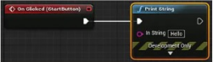

Execution Pin and the Order of Execution

The triangle pins we connect in are called execution pins, and these pins show the flow of the program. When we are programming, we write down a sequence of instructions to tell the computer what to do. The direction of the triangles and the lines connected to them shows the order of the instructions to execute, or we call the order of execution.

In this case, the program flows left to right. It can be read as:

The button is clicked, then do Print String.

The execution pin on the left side of the node is called an execution pin, and the execution pin on the right side of the node is called out execution pin.

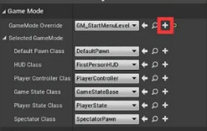
Create level GameMode.

- Create a new folder called GameModes in the Blueprints folder.

- Go to the World Settings panel, and under the Game Mode section, click on the "+ " sign on the right of the GameMode Override setting.

- In the pop-up Create New GameMode window, navigate to the GameModes folder, type in GM_StartMenuLevel in the Name setting, and press OK.

GameMode

GameMode is part of the framework Unreal Engine adapts in the default setting. GameMode controls the major components of the game, like the number of players in the game, character the player is controlling, and the heads-up display (HUD). GameMode also controls the rules of the game, like the win-lose conditions, level transitioning.

Unreal Engine has a complete and mature framework that is battletested by many games. We are going to stick with the Unreal Framework. However, you can program everything from scratch if you wish to.

Add our UI to the viewport using GameMode.

- Go to the GameModes folder and double click to open GM_StartMenuLevel.

- Click the Event Graph tab above the viewport in the middle to switch to the Event Graph. Create a Create Widget node by right clicking and searching.

- Click on the drop-down menu of the Class settings of the Create Widget node and set it to our WBP_StartMenu.

- Connect the execution pin from the Event BeginPlay to the input execution pin of the Create Widget node.

- Create a Get Player Controller node (again, just right click and search).

- Connect the Return Value output pin of the Get Player Controller node to the Owning Plaver input pin of the Create Widget node.

- Create an Add to Viewport node and connect the out execution pin of the Create Widget node to the input execution pin of the Add to Viewport node.

- Connect the Return Value output pin of the Create Widget node to the Target input pin of the Add to Viewport node (as shown below). Play the game now, and the Start Game button should appear in the viewport.

- Click on the button, and a hello gets printed at the upper left corner of the screen.

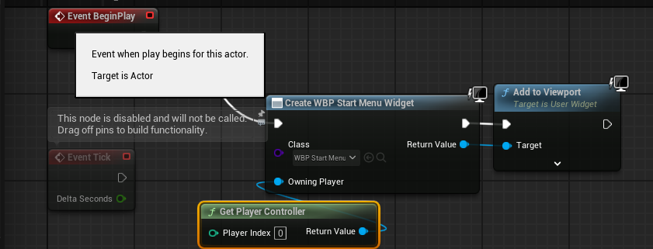

Copy BP here

Functions

The Create Widget, Add to Viewport, and Get Player Controller nodes are all functions. Functions perform certain tasks and sometimes take inputs and spit out outputs. Functions can also be considered as reusable pieces of code that we can use multiple times. The inputs are called arguments of the function, and the outputs are called return values. In the realm of Blueprint, arguments are also called parameters.

Make the button load our L_LevelOne

- Use the default level, or use Fab to download a free sample level such as this one. This is the level this tutorial will be using. Copy the level to your Level folder and rename the copy L_LevelOne.

- Open the WBP_StartMenu and go to the Event Graph by clicking the Graph button at the upper right corner of the window.

- Delete the Print String node, create an Open Level node, and type in L_LevelOne in the Level Name.

- Connect the output execution pin of the On Click(StartButton) node to the input execution pin of the Open Level node (as shown). Run the game and press the button, then the L_LevelOne is now open, and we can start playing.

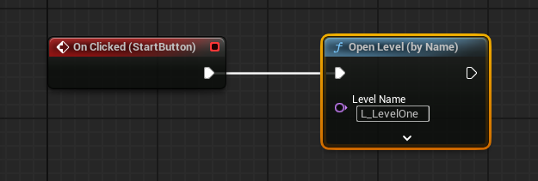

So far, everything works fine, but there are two design flaws in our coding style.

Problem 1: The UI should only be in charge of taking input from the player and not deal with direct tasks like opening a level.
- What if we have some conditions or rules that prevent the loading of another level?
- Like the player is not finished with all the tasks needed?
- Is UI going to handle all these? If we make the UI handle all these, what if we want to create a new UI? Do we have to rewrite all these in the new UI?

Problem 2: We typed in L_LevelOne in the Level Name of the Open Level function, so it is going to open L_LevelOne. Imagine that you have to load L_LevelOne in other places also, then you need another Open Level with L_LevelOne in its Level Name. It would be nice if we can change it in one place only.

Refactoring Our Load Level Mechanic

Moving Open Level function to the GameMode.

- Open our GM_StartMenuLevel and go to the Event Graph.

- Right click and search for a custom event, and choose the Add Custom Event to add a new custom event. A custom event is like a function that we can call somewhere else.

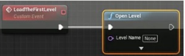
- Name this custom event to LoadTheFirstLevel (you can select it and press F2 to rename it).

- Create an Open Level Node, and connect the output execution pin from the LoadTheFirstLevel custom event to the input execution pin of the Open Level node

Use a variable to represent the name of the first level.

- Go to the Variables section under the My Blueprint panel located at the bottom left corner of the window.

- Click on the “ + " sign at the right of the Variable label. A new item called NewVar_0 got added to the list under the variable section. This NewVar_0 is a variable.

Variable

Variables are containers that store data in them, and the data they store can be changed or used somewhere else. A variable has three essential aspects:

- 1. The name of the variable.
- 2. Variable type. It can be a number, a letter, or a custom type.
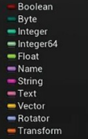
- 3. The value of the variable. Variables can be passed around, and any other part of the code can use the values of the variables.

Variable Types

Variable types are strict in Blueprint and many other programming languages. One type of variable should not be used as other types.

To the right shows the basic variable types Blueprint has. Every type of these variables has a color associated with them. You know that the two variables are the same type if they have the same color.

- For this NewVar_0 variable, we want to give it a name called FirstLevelName. With the NewVar_0 selected, go to the Details panel and set the Variable Name to FirstLevelName.

- The variable type of the variable should be Name because we are going to use it as the input of the Open Level function. The Level Name input of the Open Level function is of the type Name. In the Details panel, click the drop-down menu of the Variable Type setting and select Name.

- The value of this variable should be L_LevelOne. To change the value, we have to press the Compile button first to commit the changes we have made. After clicking the Compile button, go back to the Details panel and set the First Level Name under the Default Value section to L_LevelOne.

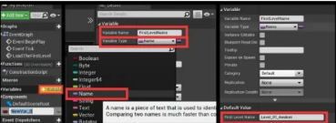

Use our variable as the Open Level input.

- Drag the FirstLevelName variable from the Variables to the Level Name input pin of the Open Level node (as shown below).

- Press Compile and save to commit the changes.

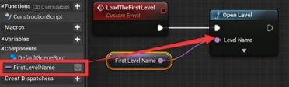

Copy full GM_StartMenu BP here (including above code and Event BeginPlay)

Make the UI call the LoadTheFirstLevel event.

- Go back to the WBP_StartMenu and delete the Open Level node.

- Create a Get Game Mode node and a Cast to GM_StartMenuLevel node.

- Connect the Return Value of the Get Game Mode node to the Object input of the Cast to GM_StartMenuLevel node.

- Drag the GM Start Menu Level output pin of the Cast to GM_StartMenuLevel node to an empty area.

- In the pop-up menu, search for Load the First Level and press the Enter button to create a call to the LoadTheFirstLevel event. The execution pins between the Cast To GM_StartMenuLevel and the Load the First Level node get automatically connected. The GM Start Menu Level now feeds in the Target input of the Load the First Level node.

- Finally, don't forget to connect the On Clicked(StartButton) to the Cast to GM_StartMenuLevel node

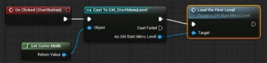

Copy BP here

Custom Variable Types

The Name variable type is not a built-in variable type of the low-level language Unreal uses (C++). It is a custom variable type that Unreal developers created for Unreal Engine only. There are more custom variable types than built-in types.

Make a Sliding Door Class

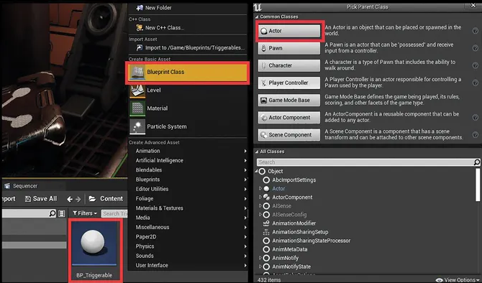
Create a Triggerable class.

- Go back to the L_LevelOne level, and create a new folder called Triggerables in the Blueprints folder.

- Right click in the Triggerables folder, and select Blueprint Class; any class we create in the editor is a blueprint class.

- In the Pick Parent Class pop-up window, click Actor. A new blueprint is now added to the folder, rename it BP_Triggerable.

Parent Class

When creating a class, we can choose to give it a parent class (or not to). A class with a parent class automatically has all the variables and functions of its parent, or in other words, they can do whatever their parent can do.

Add a trigger to the BP_Triggerable.

- Double click to open the BP_Triggerable blueprint class. If you got a window like shown below, just click the Open Full Blueprint Editor to open it with the full editor.

- Click on the Add Component button at the upper left corner of the window.

- Type in box collision and press Enter to add a box collision component. Select the new component and press F2 to rename it Trigger.

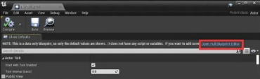

Add an on component begin overlap event.

- Select the Trigger, go to the Details panel, scroll down to the bottom, and find the Events section. Click on the plus button on the right of the On Component Begin Overlap label.

- A new event called On Component Begin Overlap (Trigger) is created in the event graph.

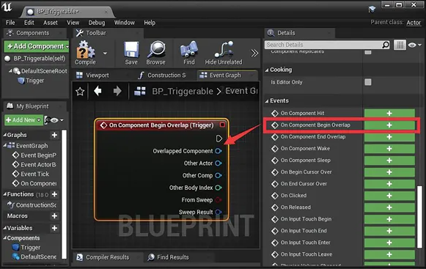

Add an on component end overlap event.

- Select the Trigger again and go to the Details panel; this time, click on the green plus button of On Component End Overlap. This creates another function called On Component End Overlap (Trigger).

- The On Component Begin Overlap (Trigger) event will be called when some other actors start overlapping with it. The On Component End Overlap (Trigger) event will be called if other actors stop overlapping with it.

Create custom events.

- Right click in the empty place and type in “custom event”, press Enter to create a custom event, and name this new custom event Overlapped.

- With this custom event selected, go to the Details panel. Hover the cursor on the “ + " sign on the right of the label of the Inputs section, and click to add a new parameter.

- Under the Inputs section, type in Other Actor as the name of the new parameter.

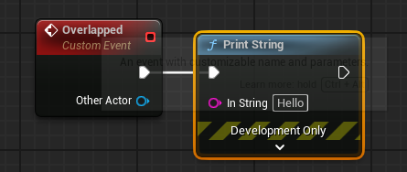
- Click on the Boolean to open the drop-down list, search for Actor, and select Actor → Object Reference. This parameter is now an input pin of this new Overlapped event, and it is of the Actor class.

- Create a Print String node, and connect the out execution pin of the Overlapped event to the in execution pin of the Print String node.

- Drag the Other Actor output of the Overlapped event to the In String input pin of the Print String node. Unreal creates a Get Display Name node automatically in between to get the name of the Other Actor input and pass that to the In String of the Print String node.

- Create another custom event and call it UnOverlapped.

- Set the UnOverlapped event the same way we did for the Overlapped event.

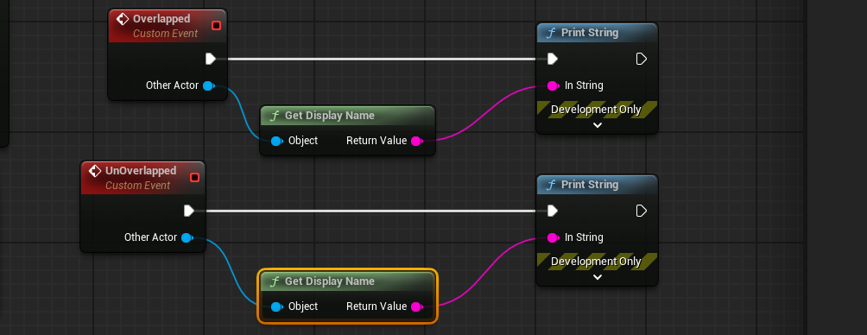

Copy BP here

Add a call to the custom events.

- Right click in the empty space, search, and create an Overlapped node and an UnOverlapped node. These two new nodes are function calls to the Overlapped and UnOverlapped events we created.

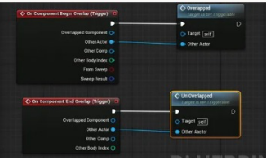
- Connect the out execution pin of the On Component Begin Overlap (Trigger) to the in execution pin of the Overlapped node.

- Connect the Other Actor output pin of the On Component Begin Overlap (Trigger) to the Other Actor input pin of the Overlapped node.

- Connect the On Component End Overlap (Trigger) and the UnOverlapped node in the same way we connect the On Component Begin Overlap (Trigger) node and the Overlapped node.

Go back to the Content Browser, and drag the BP_Triggerable to the level to create an instance of BP_Triggerable. Remember where it is, play the game, and walk over it.
You can now see that the name of the FirstPersonCharacter got printed out at the upper left corner of the UI. The code we did translate into plain English is:

When an actor overlaps and stops overlapping the trigger, print the пame of that actor.

However, we only want the player and the enemy to be able to trigger this. Let's solve this problem by checking the class type of the actor that triggered it.

Add checking to the class of the actor.

- Go to the FirstPerson/Blueprints folder, and double click to open the BP_FirstPersonCharacter class.

- Click on the Class Settings button, and you can find that the Parent Class of this FirstPersonCharacter is Character

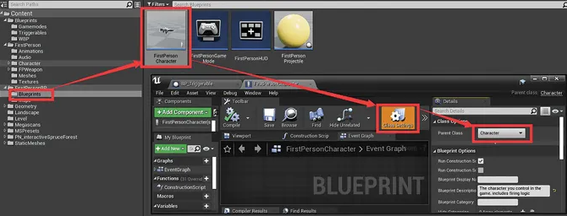

Character

A character can move around the level and can be possessed by the player or AI. For most of the time, we would use Character as the parent class for a player character or Al-controlled enemy. In this case, if we want to make sure that only the player or the enemy can trigger it, we just need to check if the overlapped actor's parent class is Character.

- Go back to the Event Graph of the BP_Triggerable class, and drag the Other Actor output pin of the On Component Begin Overlap (Trigger) node out to an empty area. Release the mouse, and a list of actions we can do to this actor appears.

- Search for GetClass and hit Enter to create a GetClass function call. This function returns the class of the Other Actor.

- Drag out the Return value output pin and search for Class Is Child Of and hit Enter to create a Class Is Child Of function call.

- Set the parent class argument of the Class Is Child Of to Character. The pin of the Return Value of this Class Is Child Of function is red. A variable of red color is of type Boolean. A Boolean variable has two possible values: true or false.

- In this case, if the Test Class is the Child of the Parent Class, the return value is true; otherwise, the return value is false. Hold down the B button and click anywhere to create a Branch node.

- Connect the Return Value of the Class Is Child Of to the Condition input pin of the Branch node.

- Connect the out execution pin of the On Component Begin Overlap (Trigger) to the in execution pin of the Branch node. This Branch node is not a function. It is a flow control statement. If the Condition input is true, the execution flow continues after the True out execution pin. Otherwise, the flow goes toward the False execution pin.

- Connect the True out execution pin of the Branch node to the in execution pin of the Overlapped node. This part of the code can now translate in plain English as:

If the class of the Other Actor is the child of the Character class, then call the Overlapped function.

- Set up the same parent class checking in the On Component End Overlap (Trigger)

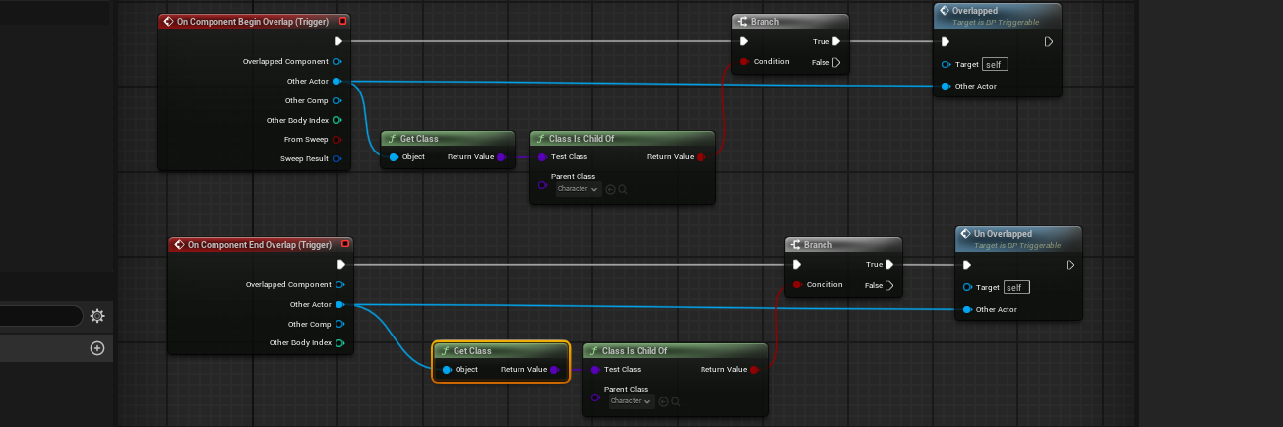

Copy BP here

Create a sliding door class that inherits the BP_Triggerable.

- Go back to the Triggerables folder, right click on the BP_Triggerable class, and select Create Child Blueprint Class.

- Name the new class BP_SlidingDoor. Double click to open it.

- Under the Components panel, you can see that there is already a Trigger component, and it is Inherited from the BP_Triggerable class. Components are the same as member variables, and they are called components just to conceptually make more sense. Like what we have mentioned before, the child class automatically got (inherits) all the member variables and functions the parent class has.

Add the door meshes to the class as static meshes.

- Go to the level named FirstPersonLevel for prototyping.

- Open the Fab window, search for sci-fi doors, and add these doors to your project.

- Go to the SciFi Doors/Meshes folder in the Content Browser.

- Select the SM_Frame, SM_DoorLeft, and SM_DoorRight meshes in the folder and drag them to the component list of the BP_SlidingDoor to add all three meshes as static mesh components to the BP_SlidingDoor class. (You can also do this by selecting them, then adding a static mesh to the Components list manually). You can now see the doors in the viewport of the class

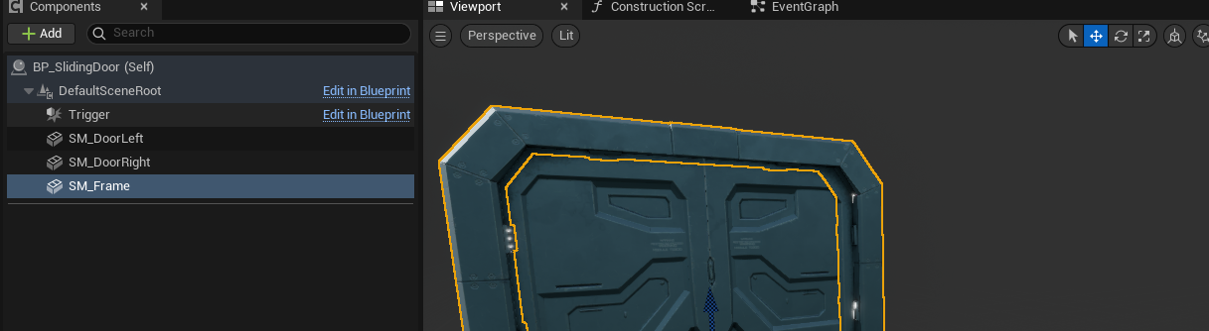

Add variables to store the door open position.

- Left click to select the left door in the viewport.

- Hit W to switch to Move and move it to slide it open.

- Go to the Details panel, right click on the Location label under the transform section, and select Copy. Add a variable by pressing the " + " sign in the Variables section and name the new variable L_DoorOpenPos. Go back to the Details panel, аnd change the Variable Type to Vector.

- Press the Compile and Save button to commit all the changes. Go back to the Details panel.

- Right click on the L_DoorOpenPos label under the Default Value section and select Paste. This L_DoorOpenPos variable now stores the open position of the left door.

- Create another vector variable called R_DoorOpenPos to store the open position of the right door (as shown). Don't forget to move the doors back afterward.

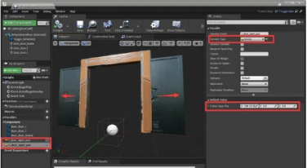

Create function overrides.

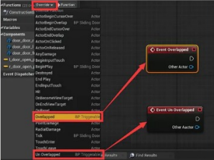
- A child class inherits all functions its parent has. So our BP_SlidingDoor has the Overlapped and UnOverlapped functions the BP_Triggerable class has. However, we want different behavior when we trigger the door. A child class can override a parent function to redefine what the function does in the child class.

- Go to the My Blueprint panel, hover the cursor above the Functions label, and click on the Override button.

- Select Overlapped in the drop-down list to create an override of the Overlapped function. An Event Overlapped node was created in the Event Graph. This Event Overlapped event looks like a regular custom event, but it is an override of the Overlapped event of the parent class.

- Go ahead and create an override to the UnOverlapped function as well.

Test our override events.
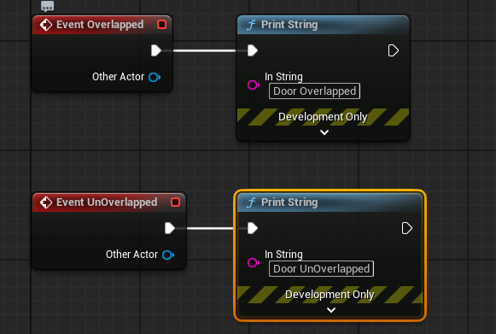
- Add two Print String nodes, call one of them with the Event Overlapped, and change the In String to “door overlapped”.

- Call the other one with the Event UnOverlapped and change the In String to “door unoverlapped” (as shown).

- Go to the Content Browser and drag the BP_SlidingDoor to the level and place it side to side with the BP_Triggerable we placed earlier.

- Play the game, and you can see "door overlapped" got printed when you approach the door, and "FirstPersonCharacter" got printed when you approach the BP_Triggerable.

- Note: You may have to increase the size of the BP_SlidingDoor trigger to touch it.

Print String may not be very useful for creating gameplay. However, it is a fantastic testing tool; use it to print out information to verify if the code behaves as expected.

Why?

So why do we go through the trouble of making a parent class and a child class? Well, there could be other stuff in the game that can be triggered. Let's say we need to create an automatic light that can be triggered if the player gets close. If we don't have a parent class, we have to create everything from scratch, including the box collision component and the overlapping events. With the BP_Triggerable parent class, we can just inherit from it and overwrite the Overlapped and UnOverlapped functions.

Create a timeline.

- Delete the two Print String nodes.

- Right click and search for Add timeline and press Enter to create a timeline. Name the timeline DoorOpenAmount and double click to open it.

- There is currently nothing in the timeline; click the “+ Track " button to add a float track. We are now creating an animation curve.

- You can now type in DoorOpenAmount to rename this float track and hit Enter to commit

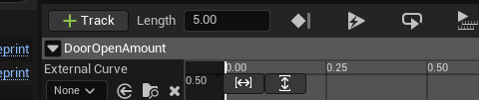

Add keys to the animation.

- Right click anywhere in the coordinates and select Add Key to CurveFloat_1 to add a key to the animation curve.

- A diamond-shaped point was added to the animation curve, and this point is a new key. With the new key selected, set the time and value at the top of the graph to 0 and 0. This new key now moves to the (0, 0) coordinate.

- Add another key and set its time and value to 1 and 1, respectively. Also, set the Length attribute of the float track to 1 at the top of the graph (as shown). You can use the same way we navigate the Event Graph to navigate the graph of the timeline.

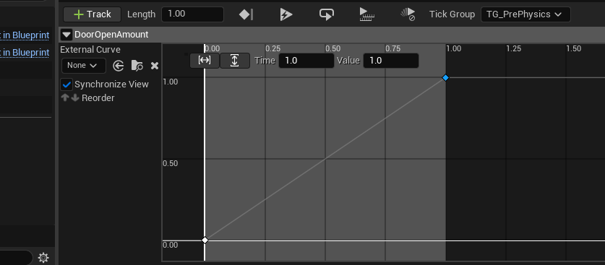

Use the timeline to drive the door movement.

- Go back to the Event Graph, and create a Lerp (Vector) node by right clicking and searching.

- Connect the DoorOpenAmount output pin of the DoorOpenAmount timeline node to the Alpha input pin of the Lerp (Vector) node.

- Drag the L_DoorOpenPos from the Variables section in the My Blueprint panel to the B input pin of the Lerp (Vector) node.

- Keep the A input pin values as it is. Drag the DoorLeft static mesh component from the Components panel to the graph to create a reference for it.

- Drag out the DoorLeft output pin and type SetRelativeLocation and hit Enter to create a SetRelativeLocation node.

- Connect the Return Value of the Lerp (Vector) node to the New Location input pin of the SetRelativeLocation node.

- Finally, connect the out execution pin of the Event Overlapped node to the Play execution pin of the DoorOpenAmount timeline node.

- Connect the out execution pin of the Event UnOverlapped node to the Reverse execution pin of the DoorOpenAmount timeline node.

- Connect the Update out execution pin to the in execution pin of the SetRelativeLocation node

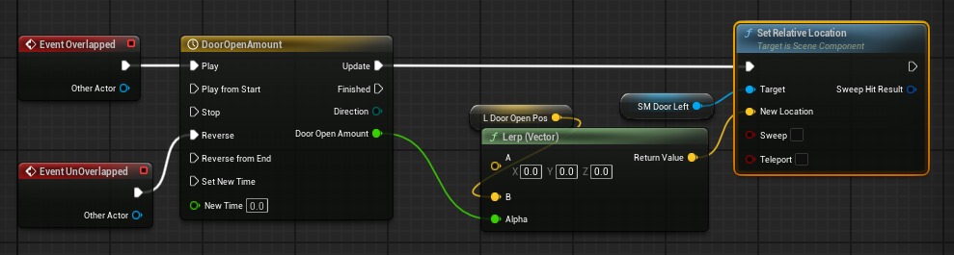

Copy BP here

What we did here can translate to plain English as:

When overlapped, play the animations in the timeline and update the relative location of the left door. The relative location of the door is (0, 0, o) at the beginning of the animation and becomes L_DoorOpenPos at the end of the animation. When someone stops overlapping, reserve the current animation.

Set up the right door.

- Set up the right door the same way we set up the left door. The difference this time is that the SetRelativeLocation node of the right door is after the SetRelativeLocation node of the left door. They are also sharing the same timeline node.

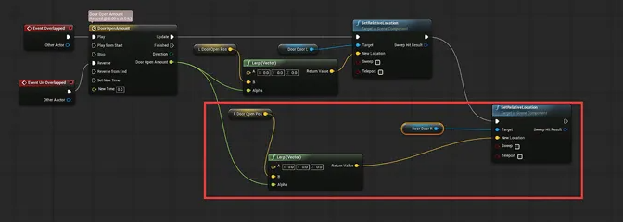

Copy new segment here (you will have to connect it)

Scale the trigger box.

- The trigger box is too small for our sliding door. Go to the viewport of the BP_SlidingDoor Blueprint, select the trigger, and scale it up like shown.

- Go back to the level, and you should see the BP_SlidingDoor we placed in the level is also updated with the bigger trigger box.

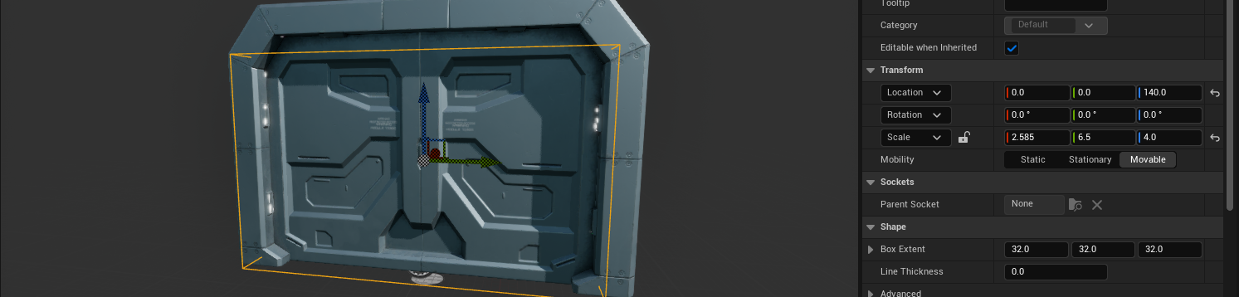

Play the game again, and you will notice that we still cannot go through the door even if it opens as expected. This is due to the collision setup of the door frame.

Check door frame collision.

- Go to the SciFiDoor/Meshes folder and double click to open the SM_Frame static mesh.

- Click on the Collision button at the top of the Asset Editor and select Add Simplified Collision. You can now see a green box showing up in the viewport. This green box is the collision shape of this model

Fix the door frame collision.

- Click on any edge of the green collision primitive of the door frame to select it.

- Use the translation tools to scale and move it, so it covers one side of the column.

- Hold down Alt and drag to create a copy of the primitive and drag it to cover the other side of the column.

- Drag out another copy and tweak it to make it cover the upper beam of the door

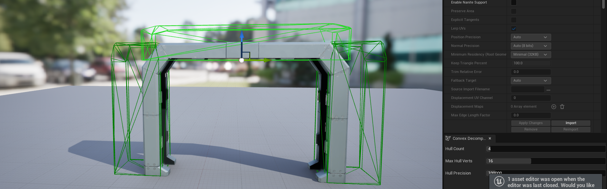

Save the asset and play the game again. This time, we should be able to go through the door.

Many beginner programmers may think that their job of creating a sliding door is done here, and it might be true in some situations. However, remember the general process of programming we have talked about? What is missing here? The answer here is refactoring

Creating the Function

Let's open BP_Triggerable and go to the Event Graph. The code seems all good and pretty clean as well. But there is an important part of the code that has its purpose untold. What does the GetClass and Class Is Child Of function do for our game?

As the creator of the code, we can say with great certainty that this piece of code ensures only the player and the enemy can trigger it. And the odds are high for another programmer to assume the purpose of this piece of code correctly. This is too simple. However, even the simplest thing in the code could cause bugs that we cannot detect, and making the purpose of any piece of code clear is essential. Let's enhance it by wrapping it with a function to make the purpose clear.

Create a function to check if the other actor should activate the trigger.

- Hover the cursor over the label of the Functions section under the My Blueprint panel.
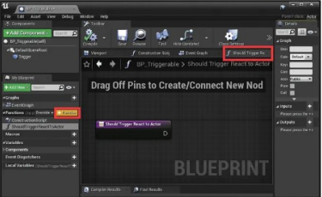
- Click on the Function button to create a new function.

- Type in ShouldTriggerReactToActor as the name of the new function. A new tag got added to the right of the EventGraph tab, and it is now highlighted. We are now in the body of the function.

Add input and output.

- Just like how we add input to our Overlapped and UnOverlapped event, we can add input to our function. Again, functions and events are the same.

- Go to the Inputs section of the Details panel, press the " + " sign to add a new input, and set its name to ActorToCheck and its type to Actor.

- Add an output and name it ShouldReact, and change its type to Boolean.

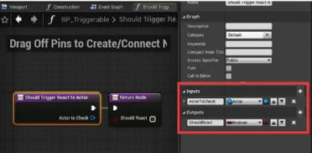

Implement our function.

- Create a GetClass node and a Class Is Child Of node.

- Connect the Actor to Check output pin of the Should Trigger React to Actor to the Object input pin of the GetClass node. You may have to pull out of the pin to get the right node.

- Connect the Return Value of the GetClass node to the Test Class input of the Class Is Child Of node.

- Connect the Return Value of the Class Is Child Of to the Should React input of the Return Node.

- Set the Parent Class parameter of the Class Is Child Of node to Character

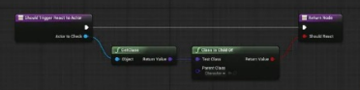

Copy BP here

Use the Function.

- Click on the Event Graph tab to go back to the Event Graph. For the On Component Begin Overlap (Trigger), delete the GetClass and Class Is Child Of nodes and create a Should Trigger React to Actor node by right clicking and searching.

- Connect the out execution pin of the On Component Begin Overlap (Trigger) to the in execution pin of the Should Trigger React to Actor node.

- Connect the Other Actor output pin of the On Component Begin Overlap (Trigger) to the Actor to Check input pin of the Should Trigger React To Actor node.

- Connect the out execution pin of the Should Trigger React to Actor node to the in execution pin of the Branch node.

- Finally, connect the Should React output pin of the Should Trigger React to Actor node to the Condition of the Branch node. Do the same thing to the On Component End Overlap (Trigger).

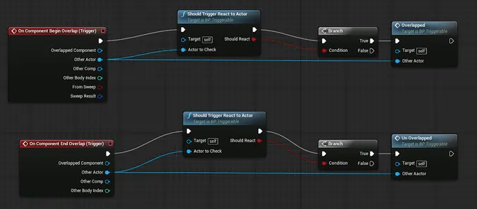

Copy BP here

Play the game again, and the behavior of the door should remain the same. There are two major improvements here:

1. The Should Trigger React to Actor is self-explanatory. The purpose is very clear.

2. If we need to change the criteria, we just need to change the body of the function. And both events should work right away.

